**1. Generate the list of customer has per age and profession and display them according to ascending order of the age.**

select AGE,JOB from CUSTOMERDETAILS order by AGE;

**output:**

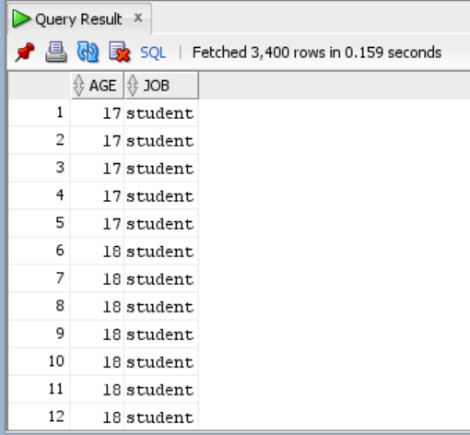

**2. Generate the list of customer who have no housing loan and personal loan.**

select customer_id from CUSTOMERDETAILS where housing='no' and loan='no';

**OUTPUT:**

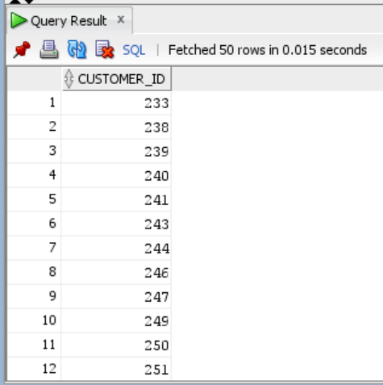

**3.Generate the list of customer who has credit and has been contacted more than 2 times during the campaign.**

select cb.customer_id,cb.default1,cp.campaign

from CUSTOMERDETAILS cb join CAMPAIGNDETAILS cp

ON cb.customer_id = cp.customer_ID

where cp.campaign>2 and cb.default1 like 'yes'

**OUTPUT:**

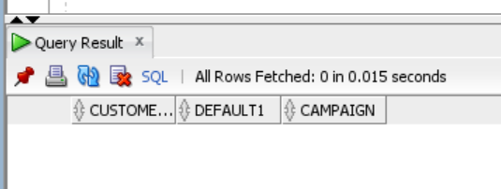

4. **Generate the list of customer who has credit and has been contacted more than 2 times during the campaign and outcome of the campaign is successful.**

select cb.customer_id,cb.default1,cp.campaign

from CUSTOMERDETAILS cb join CAMPAIGNDETAILS cp

ON cb.CUSTOMER_ID = cp.CUSTOMER_ID where cp.campaign>2

AND cb.default1 like 'yes' and cp.poutcome='success';

**OUTPUT:**



**5. Generate the list of customer who has credit and and has been contacted more than 2 times during the campaign and outcome of the campaign is failure and who have been contacted in the month of June and also display the day contacted.**

select cb.customer_id,cb.default1,cp.campaign

from CUSTOMERDETAILS cb join CAMPAIGNDETAILS cp

ON cb.CUSTOMER_ID = cp.CUSTOMER_ID

where cp.campaign>2

AND cb.default1 like 'yes' and cp.poutcome='success'and cp.month = 'jun';

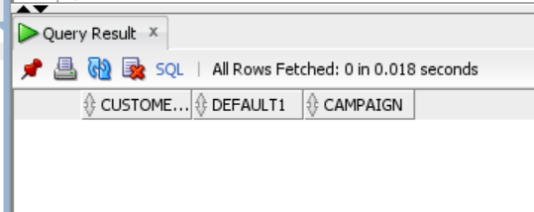

**6. Generate report giving state-wise breakup of number of customers.**

select st.state_name,count(customer_id) as numberofCustomers

from CUSTOMERDETAILS cust inner join STATECODE st on cust.state_code=st.state_code

group by st.state_name;

**OUTPUT:**

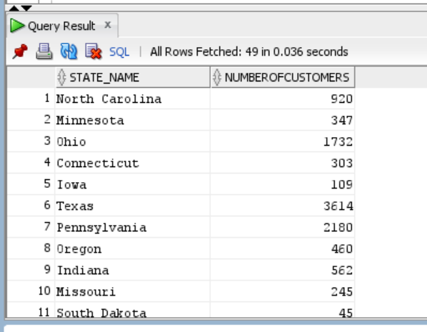

7. **Generate report giving city-wise distribution of customers**

select st.city_name,count(customer_id) as numberofCustomers

from CUSTOMERDETAILS cust inner join CITYCODE st on cust.city_code=st.city_code

group by st.city_name;

**OUTPUT:**

